**CS306 PROJECT STEP 2**

Ege Öngül

Elif Ilgın Arat

STEP 1:

Our previous webpage was like a demo, and it did not contain all the tables, relations and functions. So we started with planning what to do and how to do them. We created all the tables with their primary keys, foreign keys and constrainst with corresponding tables.

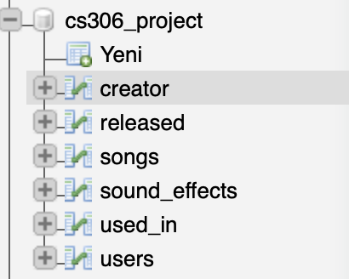

USERS: List of usernames, ages and scores

SONGS: List of songs and their length

SOUND EFFECTS: List of effect id numbers, how many times they are used and likes

CREATOR: List of the effect no and the name of that effects creator

RELEASED: List of the song name and name of who released that song

USED IN: List of effect numbers and which song they are used in.

STEP 2:

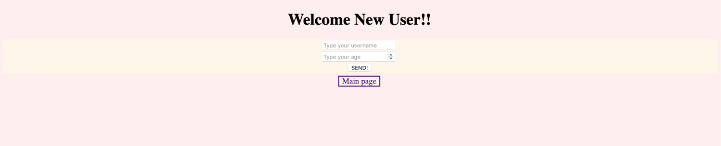For the second step, we started building our new webpage with HTML and CSS. After our applications name and our names, there are 2 options for users and 1 for non-users to choose. Non-users will choose option 1, which is a sign-up page.

First option is sign-up page. It takes 2 inputs. First is username and second is that users age. Then our program adds that specific user to the dataset, users table

Second option is creating a sound effect. It takes username and effect no as parameter. Than adds that sound effect no to sound_effects table with 0 usage and 0 likes. It also adds that user 10 point since he/she contributed to app.

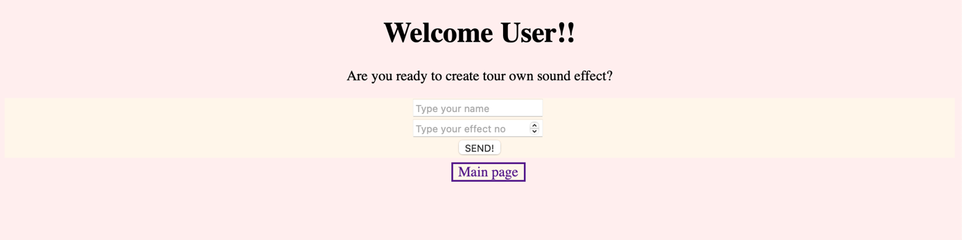

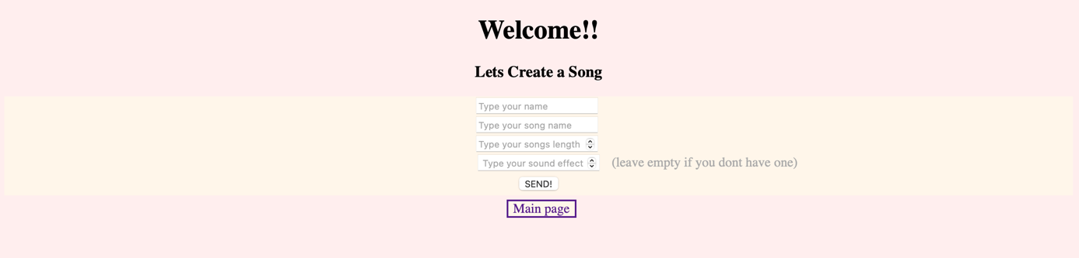Third option is to create a song. It first asks for username. Unfortunately, you cannot create a song if you are not registered as a user so you might have to go back and sign up. Then it asks for your song name, song length and effect no. Effect number is optional so if you don’t want to use any, you can leave it empty. When you successfully create your own song, program automatically adds 10 point to the user, add that specific song to the songs list, adds to released table to indicate that you created that song (with you and your songs name), and if you use any sound effects that already exists, program adds +1 usage to that sound effects and adds used_in table that effect no and song name to indicate that sound effect is used in that song. Unfortunately, you use and create a sound effect at once so if you want to use a sound effect that is not created, you will have to go back and create it first.

STEP 3:

We know that remembering each sound effect number is not easy task to do so we wanted to help the users with adding sound effect number and usage table. So that users can see which sound effects are used more than the other and it will give them an insight about which one is better. And there is another functionality that takes a song length for parameter, and it lists the songs which are longer than that specific parameter. Just to see, nothing much ☺